Title of the Abstract for ISCRE 28 [Max. two lines. Bold Times New Roman 12].
Name Lastname¹, …, Name Lastname²*
1 Affiliation and address; 2 Affiliation and address
*Corresponding author: xx@yy.zz
Highlights
- Include 3 to 4 highlights in bullet format. [Times New Roman 11].
- Max. 100 characters per highlight including spaces.
- Only the core results should be covered.
- Please do not change the selected fonts.

1. Introduction
Write your introduction here. The abstract must not exceed two pages. Please do not change the format of this abstract (font, margins, …). The document must be uploaded as a PDF file. [Times New Roman 11].
2. Methods
Report the details on the methods here, i.e. experimental methods and equipment, computing methods etc. [Times New Roman 11].
3. Results and discussion
Write the Results and Discussion here. [Times New Roman 11].
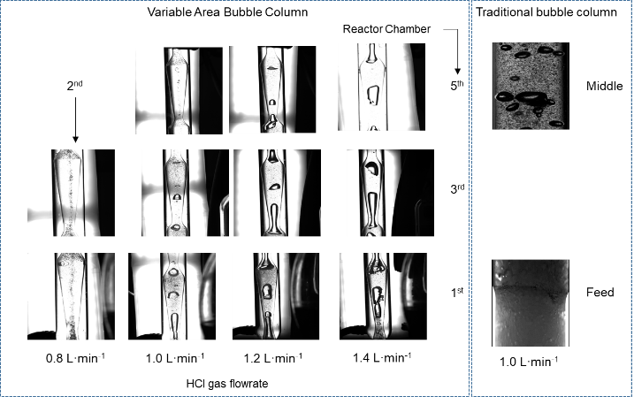
Figure 1. Caption (colored graphs and figures allowed). [Times New Roman 10].
4. Conclusions
Write the conclusions here. [Times New Roman 11].
References
The reference format is provided below [1 – 3]. [Times New Roman 10].
- C.A. de Araujo Filho, D. Mondal, S. Haase, J. Wärnå, K. Eränen, J.P. Mikkola, T. Salmi, Chem. Eng. Sci. 149 (2016) 277–295
- W.-D. Deckwer, R.W. Field, Bubble column reactors, Wiley, 1992
- A.C. Hindmarsh, ODEPACK, A Systematized Collection of ODE Solvers , R. S. Stepleman et al. (eds.), North-Holland, Amsterdam, (vol. 1 of ), pp. 55-64., North-Holland Amsterdam, 1983

Keywords
Insert a maximum of 4 keywords separated by “;”. [Times New Roman 10].

